**KRISHNA ENGINERING COLLEGE** 

(Approved by AICTE & Affiliated to Dr. APJ Abdul Kalam Technical University (Formerly UPTU), Lucknow) **Department of**

**Computer Science and Engineering (Artificial Intelligence) Data Structure using C Lab (KCS351)**

**Exercise-6: Write C Programs to illustrate the concept of Stacks.**

**List of Experiments:**

1. Write a program in C to implement stack using array with the operations: Push, Pop, Display and Exit.

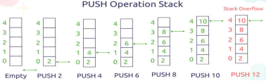





2. Write a program in C to implement stack using linked list with the operations: Push, Pop, Display and Exit. 3. Write a program in C to reverse a string using stack.

4. WAP in C to evaluate a given postfix expression using stack.

5. WAP in C to convert an infix notation to postfix notation using stack.

6. WAP in C to convert a prefix notation to postfix notation using stack.









References: https://www.dremendo.com/c-programming-tutorial/c-stack-using-linked-list, https://holycoders.com/data structures-stack/